 |  |  |  | DISTRIBUTION
PROJECT | UNR-Mathewson | REPORT # | 005
LOCATION | Reno, NV | TRIP DATE | 04/04/2024
PROJECT # | A9941.01 | ENGINEER/Observer | Hannah Bonotto
CLIENT | LMN Architects | TODAY’S DATE | 4/9/2024
CONTRACTOR | Clark Construction | PAGE | 1 OF 4

OBSERVATIONS/ACTIVITY
Time: 10:00 am
Weather: Windy 45 °F
Present: Clark Construction – Brian Peart, Chase Johnson
Magnusson Klemencic Associates – Hannah Bonotto

Clark and MKA walked the UNR Mathewson site to observe reinforcement at the slab on metal deck at Level 2 between grids 1 and 12. The structural steel between grids 1 and 12 was substantially complete as shown in Figure 1.

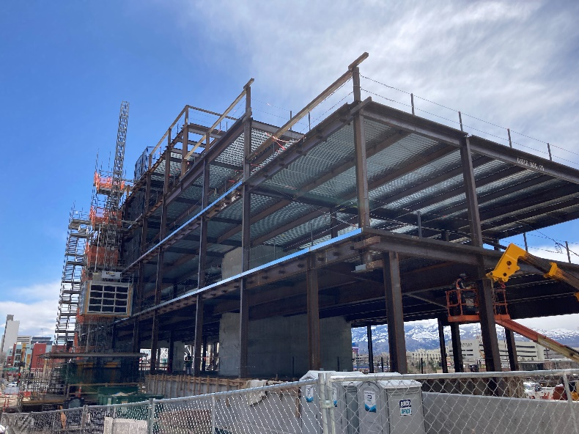
Figure 1. Overall view of steel at level 1-4 looking south from grid 4

- MKA observed the typical top reinforcement at the slab on metal deck at Level 2. The in-place top reinforcement appeared to be in general conformance with the contract documents.  Action: None | 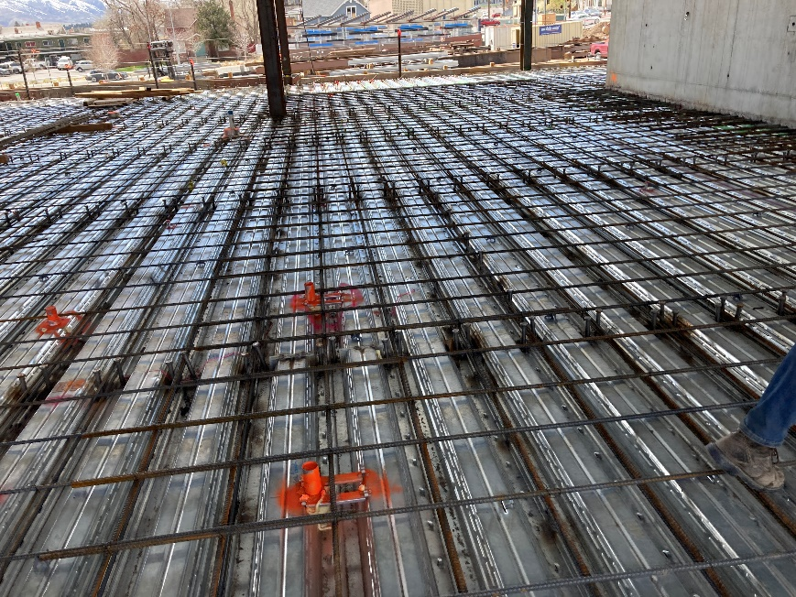  Figure 2. View of L2 reinforcement near Grid 5
- MKA observed the bottom reinforcement at the slab on metal deck at Level 2 to be higher than the cover specified in the structural drawings.  Action: Contractor to adjust reinforcement height such that cover requirements per 6/S441 are met. | 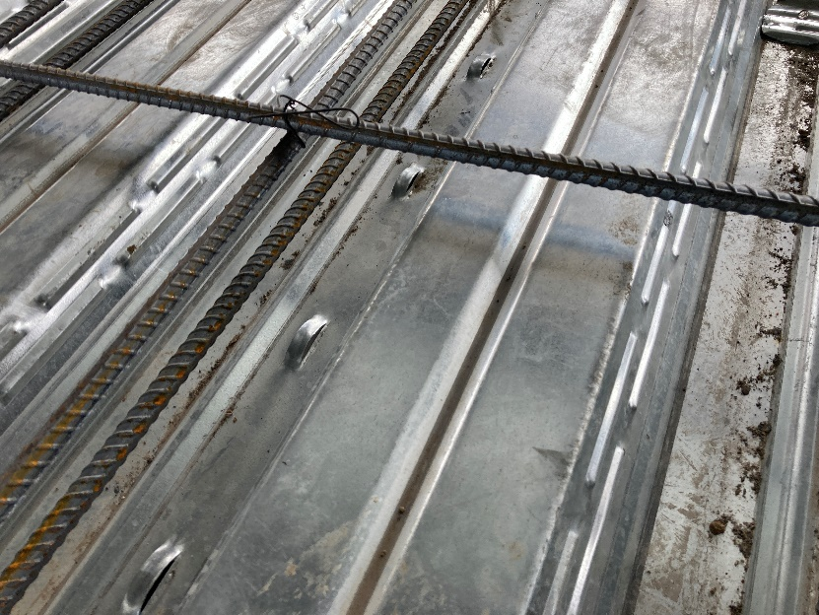  Figure 3. View of L2 SOSD reinforcement with high bottom bars

- MKA observed the installed MEP sleeves and blockouts at the Level 2 slab on metal deck. The added rebar appeared to be in general conformance with the contract documents.  Action: None. | 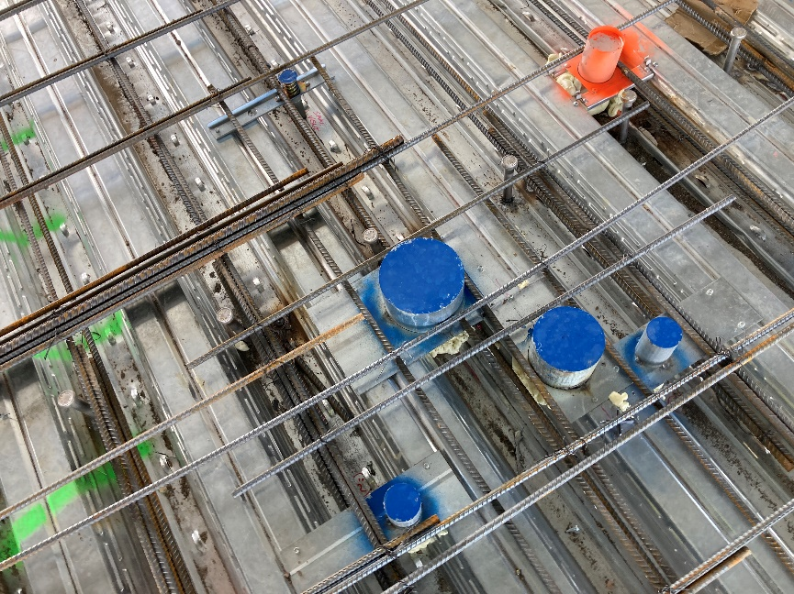  Figure 4. View of MEP penetrations at L2 slab on metal deck
- MKA observed the completed field fix at Level 2 steel to concrete C28 connection. The added plates and welds appeared to be in general conformance with the field fix RFI.  Action: None. | 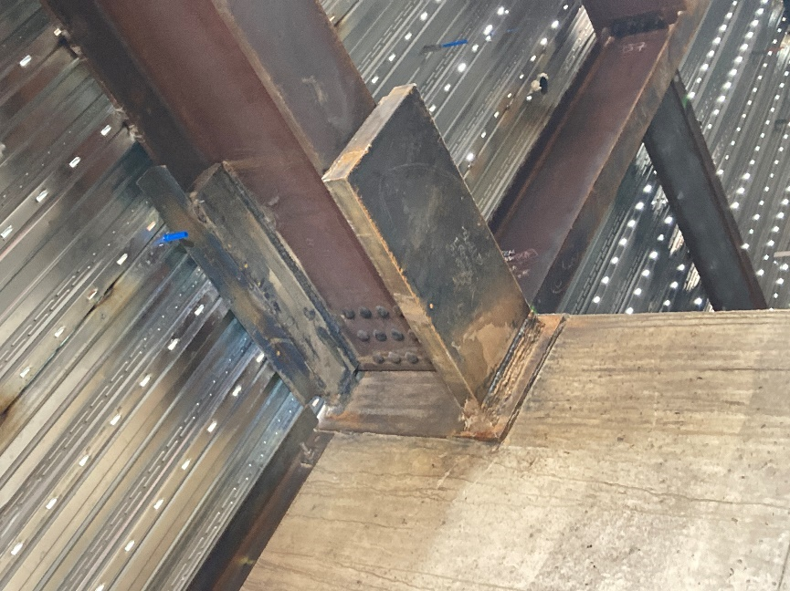  Figure 5. View looking at underside of L2 C28 field fix
- MKA observed the conflict at the #8 rebar over the top of wall on the east and west sides of the building. MKA and Clark discussed the proposed fix.  Action: See RFI 325.1 and 326.1 for the required holes in the columns and added drill and epoxy reinforcement due to the low U bars at the walls. | 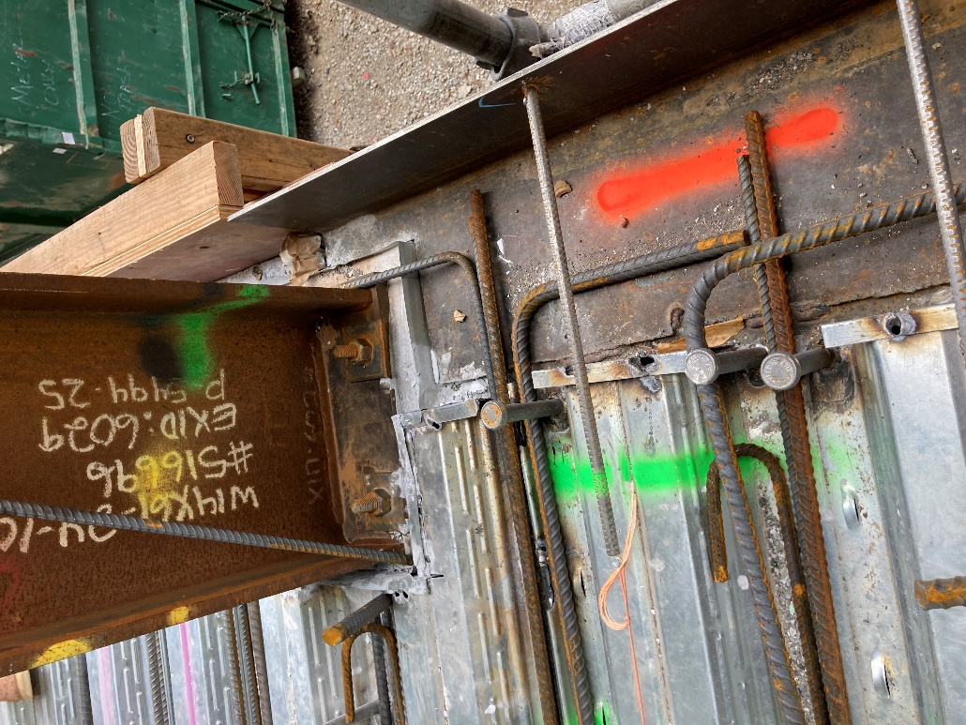  Figure 6. Added #8 bars at top of L2 perimeter walls

I:\UNR_Mathewson\Construction Admin\FieldReports\20240408_UNR_MKA Construction Observation Report_005.docx

